2Copyright for test papers and marking guides remains with *West Australian Test Papers*.

The papers may only be reproduced within the purchasing school according to the advertised Conditions of Sale.

Test papers must be withdrawn after use and stored securely in the school until 11th June2021.





**PSYCHOLOGY**

**ATAR YEAR 11**

**UNIT 1**

**2021**

**MARKING GUIDE**

**Section One: Research Methods 20% (30 marks)**

______________________________________________________________________________

**Question 1 (11 marks)**

Forty participants were tasked with learning a list of 20 words while listening to music. An hour later, the participants were randomly allocated into two equal size groups and their recall ability was assessed when they were asked to recall the list of words. Group one completed their recall while listening to the same music played at the beginning of the study, while Group two recalled the words in silence. The table below shows the results collected.

|  |  |  |
| --- | --- | --- |
|  | **Group one** | **Group two** |
| Mean | 16 | 10 |
| Range | 8 | 12 |

a) Comment on the spread of scores for each of the two groups. (1 mark)

|  |  |
| --- | --- |
| **Description** | **Marks** |
| Group one had a lower spread of scores than group two | 1 |
| **Total** | **1** |

b) Create a suitable operationalised hypothesis for this study. (4 marks)

|  |  |
| --- | --- |
| **Description** | **Marks** |
| Population mentioned | 1 |
| A predicted direction or difference | 1 |
| Operationalised independent variable: listening to music that was played during learning or not listening to music | 1 |
| Operationalised dependent variable: recall measured by number of words recalled from a list of 20 | 1 |
| *Example:* *It is hypothesised that participants will have better recall (recall more words from a list of 20) when listening to the music that was played during learning than when not listening to music.* |  |
| **Total** | **4** |

**Question 1** (continued)

d) This experiment was an independent measures design. This means that there were two groups, one for each condition of the independent variable. Explain two advantages to this study design, compared to repeated measures design. (4 marks)

|  |  |
| --- | --- |
| **Description (any two of the below)** | **Marks** |
| • Participants are less likely to drop out of the study because it is not very time  consuming.  • Participants are likely to stay interested in the study/less likely to become bored  because they only complete the recall of words once.  • In order to eliminate practice effect whereby word recall may improve due to the  repetition of the task. | 1-4 |
| **Total** | **4** |
| *Any relevant explanation accepted for two marks* | |

**Question 2 (13 marks)**

A personal trainer wanted to investigate whether the tempo of music listened to while walking affected the speed at which people walk. She predicted that the faster the tempo of music listened to, the faster the person would walk. The personal trainer used beats per minute (bpm) as a measure of music tempo and recorded the distance (km) that 20 seventeen-year-old students walked for one hour on a treadmill. Five students were allocated into four different conditions, their results shown in the table below.

|  |  |
| --- | --- |
| Condition | Average distance walked (km) |
| Condition one: walking without listening to music | 3 |
| Condition two: walking listening to music at 40-70 bpm | 2.5 |
| Condition three: walking listening to music at 85-110 bpm | 4 |
| Condition four: walking listening to music at 120-140 bpm | 5.5 |

a) Graph the results from the above information into the grid below. (5 marks)

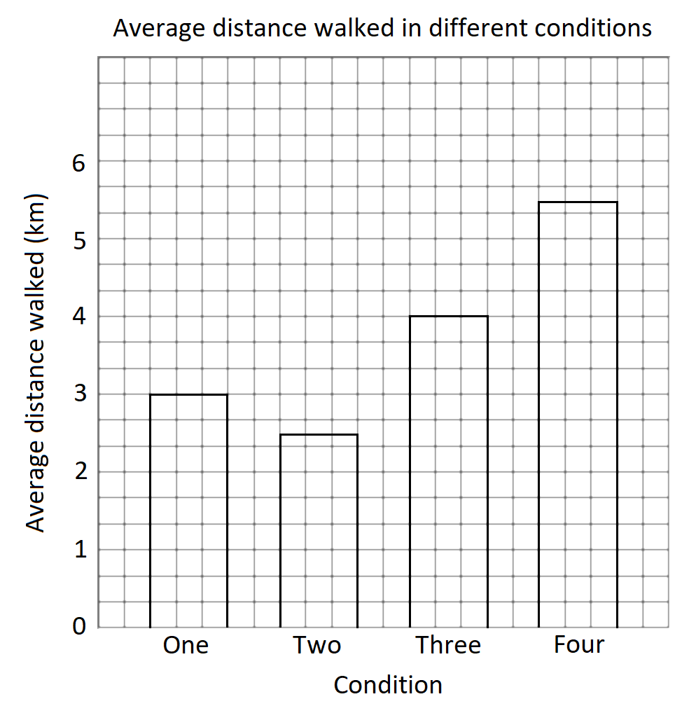

|  |  |
| --- | --- |
| **Description** | **Marks** |
| Bar graph is drawn | 1 |
| Title includes both variables | 1 |
| X and Y-axis have correct headings with appropriate units of measurement | 1 |
| Both axis have appropriate scales | 1 |
| Bars are drawn to correct heights | 1 |
| **Total** | **5** |

**Question 2** (continued)

b) Summarise the results of this study. (3 marks)

|  |  |
| --- | --- |
| **Description** | **Marks** |
| Participants walked 2.5km while listening to music at 40-70 bpm, | 1 |
| Participants walked 5.5km while listening to music at 120-140 bpm | 1 |
| Which was less than/more than | 1 |
| **Total** | **3** |
| *Must state at least two figures from the Graph (2 marks) and a trend / direction*  OR *state three figures form the graph*  Cannot include an interpretation of results | |

c) Outline **one** way that the reliability of the experiment could be increased. (2 marks)

|  |  |
| --- | --- |
| **Description (any two of the below)** | **Marks** |
| • Have each participant complete multiple trials  • Run the experiment a second time  • Increase the sample size | 1 |
| **Total** | **1** |

d) Identify **two** ethical considerations related to this experiment and explain why the personal

trainer should take them into consideration. (4 marks)

|  |  |
| --- | --- |
| **Description (any two of the below)** | **Marks** |
| • Informed consent: written consent needs to be provided by the legal guardians  of participants as they are under the age of 18 and information on the procedure and any risks outlined to the participant and caregiver prior.  • Withdrawal rights: participants may want to remove themselves from the study if  they become too tired to walk for the whole hour. | 1-4 |
| **Total** | **4** |
| *Note: one mark for identifying the ethical consideration, one mark for the explanation*  *Any relevant ethical consideration and explanation accepted for two marks each* | |

**Question 3 (6 marks)**

Miss Kicisnski had her small group of students sit a 20-mark test after no revision and then another test after allowing them two hours of revision. Their test results are shown in the table below.

|  |  |  |
| --- | --- | --- |
| Participant | Score on test without revision | Score on test after 2 hours of revision |
| 1 | 11 | 15 |
| 2 | 6 | 17 |
| 3 | 8 | 20 |
| 4 | 10 | 14 |
| 5 | 7 | 12 |

a) i. Calculate the mean score for participants who did no revision before their test, giving the

answer correct to one decimal place. (1 mark)

|  |  |
| --- | --- |
| **Description** | **Marks** |
| 8.4 | 1 |
| **Total** | **1** |

ii. Calculate the median score for participants who did 2 hours of revision before their test.

(1 mark)

|  |  |
| --- | --- |
| **Description** | **Marks** |
| 15 | 1 |
| **Total** | **1** |

b) State whether Miss Kicinski’s research is experimental or non-experimental and provide **one**

reason for your response. (2 marks)

|  |  |
| --- | --- |
| **Description** | **Marks** |
| Experimental | 1 |
| **Any one of the below**  • The independent variable has been manipulated  • There is a cause-and-effect relationship | 1 |
| **Total** | **2** |

c) The data collected for the research was quantitative. Evaluate the usefulness of collecting quantitative data compared to qualitative. (4 marks)

|  |  |
| --- | --- |
| **Description** | **Marks** |
| Benefits – At least 2  • It is less time consuming to analyse data compared to qualitative research (1)  • Results can be generalised to the population the sample was taken from (1)  • Results can be statistically analysed, which is difficult to achieve in qualitative data (1)  • It costs relatively less to run than qualitative research (1) | 1-2 |
| Disadvantages – At least 2  • It does not provide as much detailed information compared to qualitative (1)  • It does not allow for individuals to explain the reasons behind their responses (1)  • It is rigid, not allowing for flexibility as qualitative data allows researchers can adapt questions as needed (1) | 1-2 |
| **Total** | **4** |

**End of Section One**

**Section Two: Short Answer 55% (96 marks)**

______________________________________________________________________________

**Question 4 (17 marks)**

In the Netflix drama, The Queen’s Gambit, the main character is Beth, a chess prodigy who strives to become the greatest chess player in the world. The game of chess requires skills that are dominantly controlled by the left or right cerebral hemispheres in the brain.

a) For the following examples, identify whether the left or right hemisphere is more dominant.

i. Recognising that the chess board has a pattern of dark and light squares. (1 mark)

|  |  |
| --- | --- |
| **Description** | **Marks** |
| Right hemisphere | 1 |
| **Total** | **1** |

ii. The abstract reasoning required when working out which piece to move (if I move my rook

here, then I can take out his bishop). (1 mark)

|  |  |
| --- | --- |
| **Description** | **Marks** |
| Left hemisphere | 1 |
| **Total** | **1** |

b) Describe the structure and function of the corpus callosum. (2 marks)

|  |  |
| --- | --- |
| **Description** | **Marks** |
| Thick band of nerve fibres | 1 |
| Allows for communication between the two hemispheres | 1 |
| **Total** | **2** |

**Question 4** (continued)

d) i. Using the diagram below, identify the part of Phineas Gage’s brain that sustained most of

the damage during his accident (shade in or draw a line around the part). (1 mark)

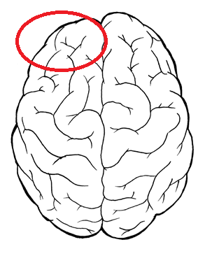

|  |  |
| --- | --- |
| **Description** | **Marks** |
| Left frontal lobe is identified on diagram | 1 |
| **Total** | **1** |

ii. Explain the impact of the damage on Phineas’ functioning. (1 mark)

|  |  |
| --- | --- |
| **Description** | **Marks** |
| The left frontal lobe was damaged | 1 |
| This is responsible for personality and emotional regulation | 1 |
| There was no damage within parts of the brain that is critical for survival. This includes the brain stem, which is required for breathing, heart rate, etc. | 1 |
| **Total** | 3 |
|  |  |

e) Describe the path messages take when travelling through a sending (presynaptic) neuron to a

receiving (post synaptic) neuron. (4 marks)

|  |  |
| --- | --- |
| **Description** | **Marks** |
| Message moves from the dendrites to the cell body | 1 |
| From the cell body down the axon to the axon terminals | 1 |
| From the axon terminal through the synapse | 1 |
| From the synapse to a dendrite of the receiving neuron | 1 |
| **Total** | **4** |
| *Note: sequence can start at any point but must flow in given order* | |

f) i. Fast-growing tissues in the brain, such as cancerous tumours, consume a lot of energy. Explain how these tumours are detected by the positron emission tomography scan (PET).

(2 marks)

|  |  |
| --- | --- |
| **Description** | **Marks** |
| Fast growing/fast metabolising cells use glucose quickly | 1 |
| PET scans involve the use of a tracer that shows areas where glucose is used up | 1 |
| **Total** | **2** |

ii. Compare and contrast an MRI scan and fMRI scan.. (2 marks)

|  |  |
| --- | --- |
| **Description (any two of the following)** | **Marks** |
| Differences  • fMRI scans do not require the use of a tracer whereas MRI scans can require  use of a tracer.  • fMRI scans take dynamic pictures whereas MRI scans take still pictures. | 1-2 |
| Similarities  Both scans use a strong, permanent, static magnetic field | 1 |
| **Total** | **3** |
| *Any relevant difference accepted for one mark* | |

**Question 5 (14 marks)**

a) Explain **one** way in which exercise can affect emotion through the production of neurotransmitters. (2 marks)

|  |  |
| --- | --- |
| **Description** | **Marks** |
| *Examples of correct answers include:*  • Exercise increases the release of mood-boosting neurotransmitters/serotonin/  endorphins. | 1  1 |
| Neurotransmitters can improve mood/reduce symptoms of  Depression/roduce a ‘runner’s high’/euphoria/happiness  *Must relate this to a particular neurotransmitter – not just saying “mood boost or better mood”* | 1 |
| **Total** | **2** |
| *Any relevant explanation accepted for two marks. One mark for identifying the function that exercise performs, one mark for the emotion that is changed/felt.* | |

b) i. Outline the effect of a hallucinogen on perception. (1 mark)

|  |  |
| --- | --- |
| **Description** | **Marks** |
| Hallucinogen alter/change perception, perceiving sounds/seeing things that are not sensed by sense organs. | 1 |
| **Total** | **1** |

ii. Name **one** recreational drug that may cause the effect described in part (i). (1 mark)

|  |  |
| --- | --- |
| **Description (any one of the following)** | **Marks** |
| • Marijuana.  • LSD.  • Ecstasy.  • Magic mushrooms (psylocibin). | 1 |
| **Total** | **1** |
| *Any relevant difference accepted for one mark* | |

c) Complete the table below. (8 marks)

|  |  |  |
| --- | --- | --- |
|  | **Amphetamine** | **Alcohol** |
| **Class of drug** | Stimulant | Depressant |
| **Effect on central nervous system** | Speeds up/increases activity | Slows/decreases activity |
| **Effect on breathing rate** | Increases breathing rate | Decreases breathing rate |
| **Effect on confidence levels** | Increases confidence levels | Increases confidence levels |

**Question 6 (16 marks)**

When viewing stimuli, part of the image projected onto the retina of the eye is obstructed by the spot at which the optical nerve joins the retina. This spot is known as the ‘blind spot’.

a) Name the process that allows the brain to fill in the gap formed by the blind spot and form a

whole coherent image. (1 mark)

|  |  |
| --- | --- |
| **Description** | **Marks** |
| Perception | 1 |
| **Total** | **1** |
|  |  |

b) Outline **one** reason why psychologists study illusions. (1 mark)

|  |  |
| --- | --- |
| **Description** | **Marks** |
| Studying illusions lets psychologists better understand the process of perception. | 1 |
| **Total** | **1** |

c) Is the image below is known as the Müller-Lyer illusion. Referring to the relevant theorists, outline one theory that explains this illusion. (3 marks)

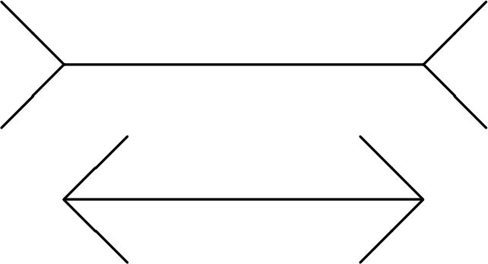

|  |  |
| --- | --- |
| **Description** | **Marks** |
| Day/Gregory | 1 |
| Perceptual compromise/perceptual expectancy | 1 |
| Compromise:  there are **contradictory visual cues,** inward facing and extending ”tails” make each line appear bigger / smaller when in actual fact they are the same length line.  OR  Expectancy  We each have memories and **experiences** of certain stimuli which allow us to form assumptions and **expectations** for when we in future see that stimuli. | 1 |
| **Total** | **3** |

d) i. List the **two** main categories of consciousness. (2 marks)

|  |  |
| --- | --- |
| **Description** | **Marks** |
| Normal waking consciousness | 1 |
| Altered states of consciousness | 1 |
| **Total** | **2** |

**Question 6** (continued)

ii. State **one** example of an altered state of consciousness that occurs naturally and **one**

example of an altered state of consciousness that can be induced. (2 marks)

|  |  |
| --- | --- |
| **Description** | **Marks** |
| Naturally occurring: sleep, daydreaming, coma | 1 |
| Induced: hypnosis, anaesthetised, alcohol-induced state, meditation, medically induced coma | 1 |
| **Total** | **2** |

e) i. A nurse is wanting to check whether a patient has been anaesthetised and is ready for

surgery. Name **one** physiological measure the nurse could use in order to determine the

state of consciousness of the patient. (2 marks)

|  |  |
| --- | --- |
| **Description (any one of the below)** | **Marks** |
| • Heart rate.  • Body temperature.  • Electrical activity of the brain.  • Galvanic skin response. | 1 |
| • Heart rate: slightly faster than the normal range/slightly slower than the normal  range  • Body temperature: around 36°C / temperature decreases by around 1 degrees  • Electrical activity of the brain: low frequency  • Galvanic skin response: low galvanic skin response | 1 |
| **Total** | **2** |

**Question 6**

g) Lucas works from home and living under a flight path, has become accustomed to the sound of airplanes flying low overhead to the point that he no longer notices the noise. The airport changed flight paths due to tarmac maintenance and for a few days no planes flew over Lucas’ house. Once the maintenance was completed and the planes started flying over Lucas’ house again, Lucas noticed the noise and it even frustrated him for the first few hours.

With reference to the above scenario, explain the two processes that are occurring. (6 marks)

|  |  |
| --- | --- |
| **Description** | **Marks** |
| Habituation | 1 |
| A form of learning whereby a person does not pay attention to a stimulus after a period of over-stimulation.  *Any relevant definition of dishabituation accepted for one mark* | 1 |
| Lucas no longer notices the noise | 1 |
| Dishabituation | 1 |
| A form of learning whereby a person has a renewed interest in a stimulus after a period of habituation.  *Any relevant definition of dishabituation accepted for one mark* | 1 |
| Once maintenance was completed, Lucas noticed the noise and even became frustrated by it. | 1 |
| **Total** | **6** |

**Question 7 (18 marks)**

a) Define the term ‘effective communication’. (1 mark)

|  |  |
| --- | --- |
| **Description** | **Marks** |
| listener **receives**, **interprets** and **understands** the message ***as it was intended*** by the speaker. | 1 |
| **Total** | 1 |

b) A psychologist is providing therapy to a new client, Chris, who was encouraged by his girlfriend

to attend, but who is not particularly open to the experience.

i. As the psychologist asks Chris questions, he is not replying to her in detail, however, he

is making gestures as he speaks. Explain how Chris’ gestures can help the psychologist

provide him with beneficial therapy. (2 marks)

|  |  |
| --- | --- |
| **Description** | **Marks** |
| The gestures he makes can reflect his **unspoken thoughts/feelings.** | 1 |
| Helping the psychologist better understand him/his needs and **how to provide therapies to assist him.** | 1 |
| **Total** | **2** |

ii. There are many examples of gestures that humans use when communicating, whether or

not they are aware they are making them. List **three** examples of gestures. (3 marks)

|  |  |
| --- | --- |
| **Description (any three of the below)** | **Marks** |
| • Nodding of the head.  • Tilting the head to one side.  • Leaning in to listen to someone.  • Making a thumbs up sign.  • Pointing with a finger.  • Stroking the beard or chin with fingers.  • Using fingers to list. | 1-3 |
| **Total** | **3** |
| *Any relevant response accepted for one mark* | |

(c) Mary, a deaf four-year-old, is learning how to communicate using Auslan. Her parents, siblings and close family friends are also learning the language. Explain why it is important that Mary’s social network learns sign language with her.

(2 marks)

|  |  |
| --- | --- |
| **Description** | **Marks** |
| Children with a hearing disability typically experience isolation in schools, however, this is only the case when the child is the only hearing-impaired student in a class. | 1 |
| It is important that Mary does not feel isolated and is able to learn socialisation through her family by being able to communicate with them  *Only one mark if the answer does not refer to it’s impact on socialisation* | 1 |
| **Total** | **2** |
| *Any relevant response* |  |

d) Outline **three** ways that the delay in her language skills would affect her development

in primary school. (3 marks)

|  |  |
| --- | --- |
| **Description (any three of the below)** | **Marks** |
| • Difficulties with communicating with peers.  • Delayed speech development.  • Delayed cognitive skills.  • Decreased writing ability.  • Decreased reading ability. | 1-3 |
| **Total** | **3** |
| *Any relevant response accepted for one mark* | |

**Question 7** (continued)

e) Robinson published a book in 2003 which drew attention to the different ways adults

communicate socially.

i. Name the verbal social skill addressed by Robinson. (1 mark)

|  |  |
| --- | --- |
| **Description** | **Marks** |
| Terms of address | 1 |
| **Total** | **1** |
| *May accept politeness, however, only if specify verbal politeness (e.g. please, thank you)* |  |

ii. According to Robinson, how a person conducts a handshake can

communicate a message. Identify one feature of a handshake and describe its

associated meaning. (2 marks)

|  |  |
| --- | --- |
| **Description** | **Marks** |
| The way in which you extend your hand/the way in which you apply pressure/the length of time you shake | 1 |
| Palm up = here to serve/submission/ Palm down = in charge, taking control/ Palm vertical = we are equals.  or  Little pressure = distrustful/ Good pressure = I can be trusted/ Too much pressure = Too confident or covering something up.  or  Long = Indicates close relationships. Usually with old friends meeting or goodbyes/ Short = Could send a negative message such as disinterested or cold. | 1 |
| **Total** | **2** |

**Question 8 (17 marks)**

a) Explain why it is difficult to define ‘intelligence’. (2 marks)

|  |  |
| --- | --- |
| **Description** | **Marks** |
| It is a hypothetical construct | 1 |
| Intelligence itself cannot be seen, only its effects can be observed | 1 |
| **Total** | **2** |

b) The multiple intelligences theory claims that there are numerous intelligences that each person

possesses.

i. Name the theorist who developed this theory. (1 mark)

|  |  |
| --- | --- |
| **Description** | **Marks** |
| Gardner/Howard Gardner | 1 |
| **Total** | **1** |

ii. Aaron is a twelve-year-old boy who aspires for a career in teaching. Using the Multiple

intelligence theory, identify one type of intelligence important to succeed in this role,

justifying your answer.

(2 marks)

|  |  |
| --- | --- |
| **Description** | **Marks** |
| Inter-personal intelligence | 1 |
| Through the role of interacting and supporting student learning, teaching requires the ability to understand the thoughts, feelings and intentions of others. | 1 |
| **Total** | **2** |
| *Any relevant response accepted if appropriately justified* |  |

iii. Describe how multiple intelligences can be used by primary school teachers in the

classroom. (1 mark)

|  |  |
| --- | --- |
| **Description (any one of the below)** | **Marks** |
| • Activities can be tailored to children to meet their individual needs  • The teacher can tailor activities to build on the strengths of children  • The interests that children have can be used to create successful learning  opportunities | 1 |
| **Total** | **1** |
| *Any relevant response accepted for one mark* | |

c) Spearman developed the two-factor theory of General Intelligence.

ii. . Identify what the ‘S factor’ refers to in Spearman’s theory. (1 mark)

|  |  |
| --- | --- |
| **Description** | **Marks** |
| Specific ability | 1 |
| **Total** | **1** |

iii. Spearman administered a range of tests on children and found scores on

tests, such as maths and logical reasoning, had strong positive correlations

with each other. Explain what this means, with reference to the role of the S

factor G factor. (4 marks)

|  |  |
| --- | --- |
| **Description** | **Marks** |
| If a child received a high score in one test/maths test  They would also receive a high score in another test/logical reasoning test | 1  1 |
| This is because the child has a high general intelligence ability  To succeed in specific abilities of logical reasoning and math | 1  1 |
| **Total** | **4** |
| *Also accept: receiving a low score on one test is related to receiving a low score on another test* | |

d) Individual intelligence testing requires the examiner to build rapport with the test taker. Outline

how this may be a benefit of individual intelligence testing as well as be seen as a limitation.

(2 marks)

|  |  |
| --- | --- |
| **Description** | **Marks** |
| Advantage  • The test taker will feel more at ease during the test. | 1 |
| Limitation  • The test will take longer overall as it takes time for the examiner to build a  positive relationship with the test taker. | 1 |
| **Total** | **2** |
| *Any relevant benefit for one mark and any relevant limitation for one mark* | |

e) Explain why scores are generally dependent on reading ability in group intelligence tests,

while in individual intelligence tests, scores are not generally dependent on reading ability.

(2 marks)

|  |  |
| --- | --- |
| **Description** | **Marks** |
| Group intelligence tests are typically pencil and paper tests that require test takers to read the questions to themselves individually | 1 |
| An examiner reads questions to the test taker in individual intelligence tests so reading ability is not critical | 1 |
|  | **2** |

**Question 9 (14 marks)**

a) Popular Australian research on the formation of adolescent groups suggests that peer groups

change over time and move through a number of distinct stages.

i. Identify the number of stages theorised in the research. (1 mark)

|  |  |
| --- | --- |
| **Description** | **Marks** |
| Five | 1 |
| **Total** | **1** |

ii. At which stage does group membership require a degree of conformity among members?

(1 mark)

|  |  |
| --- | --- |
| **Description** | **Marks** |
| Stage one | 1 |
| **Total** | **1** |

b) Provide **two** reasons why bullying is a form of anti-social behaviour. (2 marks)

|  |  |
| --- | --- |
| **Description (any two of the following)** | **Marks** |
| • Bullying is intentional behaviour  • Bullying causes harm to another person  • Bullying is viewed negatively by society | 1-2 |
| **Total** | **2** |
| *Any relevant reason accepted for one mark* | |

c) Outline **two** characteristics of pro-social behaviour. (2 marks)

|  |  |
| --- | --- |
| **Description (any two of the following)** | **Marks** |
| • No personal reward is sought after  • It involves helping another person  • It is viewed positively by society | 1-2 |
| **Total** | **2** |
| *Any relevant characteristic accepted for one mark* | |

d) Vincent is 3-months-old and cries when he requires his needs to be met. Explain why his

survival is partially dependent on his primary caregiver having the ability to feel empathy.

(3 marks)

|  |  |
| --- | --- |
| **Description** | **Marks** |
| Empathy allows for Vincent’s primary caregiver to feel sad/upset when Vincent feels sad/upset | 1 |
| Empathy motivates Vincent’s primary caregiver to satisfy Vincent’s needs so that he is no longer distressed | 1 |
| If Vincent’s primary caregiver did not have empathy, they may not be as sensitive to Vincent’s needs | 1 |
| **Total** | **3** |

**End of Section Two**

**Section Three: Extended Answer 25% (52 marks)**

______________________________________________________________________________

**Question 10 (14 marks)**

Year 12 students, Christine and Adelle, met at the Pulse Perspectives exhibition of year 12 art work at the Art Gallery of WA. They started chatting after Adelle complimented Christine on the dress she was wearing and after a few hours discussing the exhibited art together, they exchanged numbers and agreed to meet for coffee the following week. As Christine had her licence and Adelle only lived 10 minutes away, she gave Christine a lift to the café and in return, Adelle paid for Christine’s coffee and cake at the café. Over time, they became close friends.

In your answer you should:

• Define the term ‘liking’.

• Name and outline the **three** determinants of liking.

• Provide an example of how each determinant of liking can be seen between Christine and Adelle.

• Comment on the type of behaviour demonstrated by both Christine and Adelle.

• Refer to psychological evidence and understandings.

|  |  |
| --- | --- |
| **Guide to marking extended answers** | **Marks** |
| **Definition of liking** | **1** |
| Feeling fondness/attraction for someone. | 1 |
| **Elements of liking** | **9** |
| Proximity. Being in close physical distance with another person. Relate to scenario: Christine and Adelle live only 10 minutes from each other.  Similarity. Sharing commonalities with another person. Relate to scenario: Christine and Adelle both have an interest in art/both have a similar fashion sense/both like coffee.  Reciprocity. A person doing something helpful for another person in return for the help they received from them. Relate to scenario: Christine picks up Adelle and drives her to the café and in return Adelle buys Christine coffee and cake. | 1 1 1  1 1 1  1 1 1  1 |
| **Type of behaviour** | **1** |
| Pro-social  *Must comment with either an example or definition. | 1 |
| **Quality of extended response** | **3** |
| Well-developed sentences and paragraphs **and** consistent use of appropriate psychological language **and** correct spelling, grammar and punctuation. | 3 |
| Coherent response with adequate spelling, grammar, sentence structure and paragraph structure. | 2 |
| Single paragraph response or lack of paragraph structure **and/or** poor sentence structure **and/or** very colloquial language and/or poor English expression **and/or** many spelling errors. | 0-1 |
| **Total** | **14** |
|  |  |

**Question 11 (23 marks)**

In the 1960s, Paul Ekman visited people from different cultures and took photographs of their expressions given when presented with scenarios. He then asked participants from around the world to identify the emotions shown in the photographs and discovered that more than 90% of expressions were recognised around the world. Ekman theorised six common facial expressions that are recognised universally.

The ability to recognise facial expressions allows for the emotions of people around us to be identified. Emotional intelligence (EQ) became popularised in the late 1990s and many believe it is as important as IQ for social, academic and professional success.

In your answer you should:

• Describe the type of communication facial expressions are categorised under.

• List **four** common facial expressions that are universally recognised.

• Outline the **three** main concepts that make up EQ.

• Suggest **two** reasons why many people believe EQ is a valuable skill that leads to success in the

workplace.

• Define the term ‘active listening’ and, considering an individual with high EQ, provide **two** examples

to show how they could actively listen to another person.

• Refer to psychological evidence and understandings.

|  |  |
| --- | --- |
| **Guide to marking extended answers** | **Marks** |
| **Type of communication** | **1** |
| Non-verbal communication as muscle movement under the skin of the **face**. | 1 |
| **Universally recognised facial expressions (any four of the following)** | **4** |
| Anger. Surprise. Fear. Sadness. Happiness. Disgust. | 1-4 |
| **Emotional intelligence theory** | **3** |
| Emotional intelligence refers to the ability to recognise emotions we are feeling, regulate our own emotions and recognise the emotions of others. | 1 1 1 |
| **Reasons employers hire people with high EQ** | **4** |
| People with high EQ are able to recognise the emotions of others therefore are more likely to work successfully in a team. People with high EQ are able to regulate their own emotions meaning they can stay calmer in stressful work environments. *Any relevant explanation for two marks* | 1-2  1-2 |
| **Active listening** | **5** |
| Definition: engaging in a conversation while trying to empathise with what the person is saying. OR Active listening is a technique of careful listening and observation of verbal and non-verbal cues  A gentle touch on the arm or shoulder shows that the listener is physically and emotionally available to genuinely listen to what the speaker is saying.  Before responding to the speaker, the listener pays attention to nonverbal cues to work out how the speaker is feeling.  *Any relevant example for two marks each* | 1  1-2  1-2 |
|  |  |
| **Use of psychological evidence** | **3** |
| **Two** or more statements are supported with a description of relevant evidence using **three** or more sentences. | 3 |
| **Two** or more statements are provided with a brief description of relevant evidence using less than **three** sentences. | 2 |
| **One** or **two** statements are supported with reference to relevant evidence. | 1 |
| **Examples of psychological evidence** |  |
| • An explanation of how gestures, eye contact, touch, the use of space or body posture could be used in combination with emotional intelligence to more successfully communicate and interact with colleagues in the work environment. • Robinson’s social skills applied to the work environment and how they could be used in combination with emotional intelligence. • Support for Goleman’s emotional intelligence theory: EQ encourages leadership in the workplace and is a type of intelligence sought after by many businesses. • Criticism of Goleman’s emotional intelligence theory: according to Eysenck (2000), Goleman’s theory lacks statistical evidence. |  |
| **Quality of extended response** | **3** | |
| Well-developed sentences and paragraphs **and** consistent use of appropriate psychological language **and** correct spelling, grammar and punctuation. | 3 | |
| Coherent response with adequate spelling, grammar, sentence structure and paragraph structure. | 2 |
| Single paragraph response or lack of paragraph structure **and/or** poor sentence structure **and/or** very colloquial language and/or poor English expression **and/or** many spelling errors. | 0-1 |
| **Total** | **23** |
|  |  |
|  |  |